Name: Dayigil Basil Boeloeplat
Matric No: 2019/1/75427CT

Assignment 1
Question 1: Advantages of Wireless Local Loop
Answer:

Advantages of Wireless Local Loop (WLL)
- Cost-effectiveness
Wireless Local Loop systems avoid the high expense of laying physical cables, especially in large or geographically challenging areas. In traditional wired networks, installing underground or aerial cables requires extensive labor, materials, and long-term maintenance. WLL replaces much of this with wireless infrastructure such as base stations and customer antennas which is cheaper to install and maintain. This translates into significant savings for service providers and makes it easier to offer affordable connectivity.
Example: In rural mountain regions, laying copper or fiber optic cables can cost thousands of dollars per kilometer, while installing a WLL base station and antennas might cost only a fraction of that.

- Rapid Deployment
Unlike wired systems that can take weeks or months to deploy due to trenching, pole installation, and regulatory approvals, WLL can be set up within hours or days. Once base stations are in place, new customers can be connected simply by installing a small antenna or receiver on their premises. This speed makes WLL ideal for situations where urgent connectivity is needed.
Example: After a natural disaster damages existing telecom infrastructure, WLL can quickly restore communication services to affected areas.

- Flexibility & Scalability
WLL networks are inherently more adaptable than wired systems. They can easily be expanded by adding more base stations or increasing capacity through software and equipment upgrades. They can also be redeployed or reconfigured for temporary events, emergencies, or seasonal needs without wasting infrastructure.
Example: A telecom provider can boost coverage for a festival or sports event by temporarily increasing WLL capacity, then scaling it back once the event is over.

- Accessibility
WLL is especially valuable for rural, remote, or underserved communities where wired infrastructure is impractical or economically unviable. By using wireless transmission, service providers can bypass geographical barriers such as rivers, mountains, and dense forests. This helps bridge the “digital divide,” ensuring more people have access to communication, education, and online services.
Example: In remote African villages where fiber or DSL is unavailable, WLL enables schools and clinics to connect to the internet, supporting education and telemedicine.

Question 2: Discuss about Registration and Tunneling (Port-forwarding) in Mobile IP (MIP).
Answer:
Registration in Mobile IP
This is a technique in MIP used by a Mobile Node (MN) to notify its Home Agent (HA) about its current location when it moves to a foreign network. The goal is to allow the HA to update its routing information so that incoming data packets can be redirected to the MN’s Care-of Address (CoA) in the visited network. Without registration, the HA would not know where to send packets, causing communication failures.
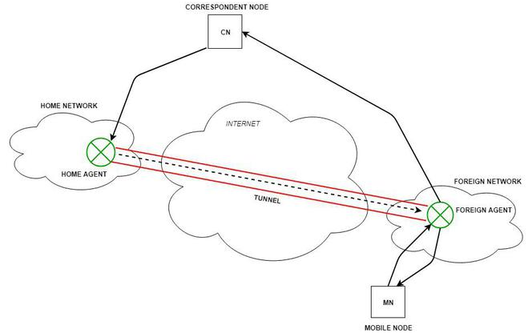
FIGURE 1: Illustration of Mobile IP Registration
https://www.geeksforgeeks.org/computer-networks/mobile-internet-protocol-or-mobile-ip/
Procedure:
- MN detects movement into a new (foreign) network via agent advertisements or solicitations.
- MN obtains a Care-of Address either from a Foreign Agent (FA) or directly (co-located CoA).
- MN sends a Registration Request to the FA or directly to the HA (in co-located cases).
- FA, if involved, forwards the registration request to the HA.
- HA authenticates the request, verifies the MN’s identity, and records the CoA in its Mobility Binding Table.
- HA sends a Registration Reply to confirm success (via the FA or directly).
- MN can now receive data packets via tunneling from the HA.

Tunneling in Mobile IP (Port Forwarding)
This is a technique in MIP where data packets intended for a Mobile Node’s home address are encapsulated and sent to the MN’s current location in a foreign network. It is essentially a form of “IP-level port forwarding” that hides the fact that the MN is not physically on its home network, maintaining ongoing connections without interruption.
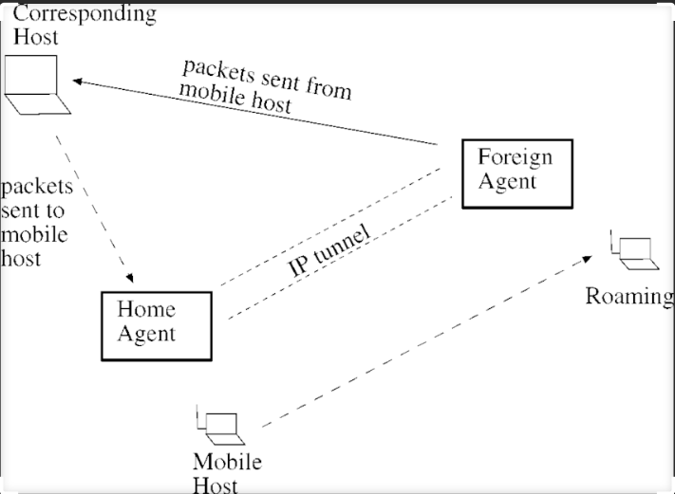
FIGURE 2: Illustration of Mobile IP tunneling
https://www.researchgate.net/figure/The-mobile-IP-tunneling_fig1_220134088
Procedure:
- A Correspondent Node sends a packet to the MN’s home IP address.
- Packet arrives at the Home Agent, which intercepts it.
- HA encapsulates the packet in a new IP header — this is called IP-in-IP tunneling.
- Outer header’s destination is set to the MN’s Care-of Address in the foreign network.
- Packet travels through the Internet to the FA or directly to the MN (co-located CoA case).
- FA (if present) decapsulates the packet and delivers it locally to the MN.
- MN receives the packet as if it came directly to its home address, keeping sessions active.

References
- Bayeh, E. (2023, September 21). Wireless local loop (WLL) – A comprehensive guide. GreenCloudVPS Blog. https://blog.greencloudvps.com/wireless-local-loop-wll-a-comprehensive-guide.php
- Cisco Systems. (n.d.). Configuring mobile IP. Cisco. https://www.cisco.com/c/en/us/td/docs/ios/solutions_docs/mobile_ip/mobil_ip.html
- GeeksforGeeks. (2023, March 6). Mobile Internet Protocol or Mobile IP. GeeksforGeeks. https://www.geeksforgeeks.org/computer-networks/mobile-internet-protocol-or-mobile-ip/
- Lenin, P. (2021, March 14). Wireless local loop (WLL) [SlideShare presentation]. SlideShare. https://www.slideshare.net/LeninPrasath/wll-237465419
- Perkins, C. (2001). Tutorial: Mobile IP. University of Colorado Boulder. https://home.cs.colorado.edu/~rhan/CSCI_7143_002_Fall_2001/Papers/Perkins_Tutorial_Mobile_IP.htm
- Ques10. (n.d.). Give the advantages of wireless local loop (WLL) over conventional local loop. Ques10. https://www.ques10.com/p/67299/give-the-advantages-of-wireless-local-loop-wll-ove/
- Scaler. (n.d.). Mobile IP. Scaler. https://www.scaler.com/topics/computer-network/mobile-ip/
- Wray Castle. (n.d.). WLL – Wireless local loop. Wray Castle. https://wraycastle.com/blogs/glossary/wll-wireless-local-loop

